**Project 3 Report**

**System configuration: (Abrar Akhyer Abir’s Laptop)**

**Processor:** Intel(R) Core(TM) i7-7660U CPU @ 2.50GHz (4 CPUs), ~2.5GHz

**Memory:** 16384MB RAM

**System configuration: (Asif Zaman’s Laptop)**

**Processor:** AMD® Ryzen 5 5600u with Radeon graphics × 12

**Memory:** 13.5 GiB

**Cache:** 16MB

**How to Run the project:**

Run this command **“*python sf_main.py*”**

**Quality Report:**

**Fingerprints Report**

|  |  |  |
| --- | --- | --- |
| **Input** | **Fingerprint** | **Length** |
| Covid_Wuhan | GTACAGTGAACAATGCTAGGGAGAGCTGCCTATATGGAAGAGCCCTAATGTGTAAAATTAATTTTAGTAGTGCTATCCCCATGTGATTTTAATAGCTTCTTAGGAGAATGACAAAAAAAAAAAAA | 125 |
| Covid_USA-CA4 | ACTTACCG | 8 |
| Covid_Australia | ATACAGTG | 8 |
| Covid_India | ACTAAGGA | 8 |
| Covid_Brazil | CGCGCTC | 7 |
| SARS_2017_MK062179 | AACCTCG | 7 |
| SARS_2003_GU553363 | CAGGAGG | 7 |
| MERS_2014_USA_KP223131 | GTCCCC | 6 |
| MERS_2014_KY581694 | CCCCTTG | 7 |
| MERS_2012_KF600620 | CAAGGGG | 7 |

Here, we can see, Covid_Wuhan has the longest fingerprint available. Since it was the first one strain of Covid-19, we think it has longest fingerprint than other strains.

**Length of the Longest Common Substrings Report**

We were able to construct the GST for all strains without reducing the size input size.

|  |  |  |  |  |  |  |  |  |  |  |
| --- | --- | --- | --- | --- | --- | --- | --- | --- | --- | --- |
| String | Covid_Wuhan | Covid_USA-CA4 | Covid_Australia | Covid_India | Covid_Brazil | SARS_2017_MK062179 | SARS_2003_GU553363 | MERS_2014_USA_KP223131 | MERS_2014_KY581694 | MERS_2012_KF600620 |
| Covid_Wuhan | - | 23769 | 19064 | 7961 | 11082 | 104 | 104 | 23 | 23 | 23 |
| Covid_USA-CA4 |  | - | 13980 | 7961 | 8896 | 104 | 104 | 23 | 23 | 23 |
| Covid_Australia |  |  | - | 7961 | 11082 | 104 | 104 | 23 | 23 | 23 |
| Covid_India |  |  |  | - | 4620 | 104 | 104 | 23 | 23 | 23 |
| Covid_Brazil |  |  |  |  | - | 104 | 104 | 23 | 23 | 23 |
| SARS_2017_MK062179 |  |  |  |  |  | - | 7878 | 20 | 20 | 20 |
| SARS_2003_GU553363 |  |  |  |  |  |  | -- | 20 | 20 | 20 |
| MERS_2014_USA_KP223131 |  |  |  |  |  |  |  | - | 3098 | 3182 |
| MERS_2014_KY581694 |  |  |  |  |  |  |  |  | - | 2890 |
| MERS_2012_KF600620 |  |  |  |  |  |  |  |  |  | - |

From the table, we can see similar types of strains has longer common substrings among them. However, if the strains vary the length of longest common substring is also reduced.

**Similarity Matrix Report:**

Since our laptop was not able to run the alignment for full input size, we have used 5000 characters for each input and perform the alignment.

**Similarity Matrix:**

|  |  |  |  |  |  |  |  |  |  |  |
| --- | --- | --- | --- | --- | --- | --- | --- | --- | --- | --- |
| String | Covid_Wuhan | Covid_USA-CA4 | Covid_Australia | Covid_India | Covid_Brazil | SARS_2017_MK062179 | SARS_2003_GU553363 | MERS_2014_USA_KP223131 | MERS_2014_KY581694 | MERS_2012_KF600620 |
| Covid_Wuhan | 5000 | 4997 | 4994 | 4984 | 4994 | 733 | 726 | 13 | 13 | 13 |
| Covid_USA-CA4 | 4997 | 5000 | 4997 | 4981 | 4997 | 730 | 723 | 13 | 13 | 13 |
| Covid_Australia | 4994 | 4997 | 5000 | 4984 | 4994 | 733 | 726 | 13 | 13 | 13 |
| Covid_India | 4984 | 4981 | 4984 | 5000 | 4620 | 725 | 723 | 13 | 13 | 13 |
| Covid_Brazil | 4994 | 4997 | 4994 | 4984 | 5000 | 733 | 726 | 13 | 13 | 13 |
| SARS_2017_MK062179 | 733 | 730 | 733 | 725 | 733 | 5000 | 4960 | 21 | 21 | 21 |
| SARS_2003_GU553363 | 726 | 723 | 726 | 723 | 726 | 4960 | 5000 | 21 | 21 | 21 |
| MERS_2014_USA_KP223131 | 13 | 13 | 13 | 13 | 13 | 21 | 21 | 5000 | 4961 | 4930 |
| MERS_2014_KY581694 | 13 | 13 | 13 | 13 | 13 | 21 | 21 | 4961 | 5000 | 4924 |
| MERS_2012_KF600620 | 13 | 13 | 13 | 13 | 13 | 21 | 21 | 4930 | 4924 | 5000 |

**Similarity Matrix Heatmap**

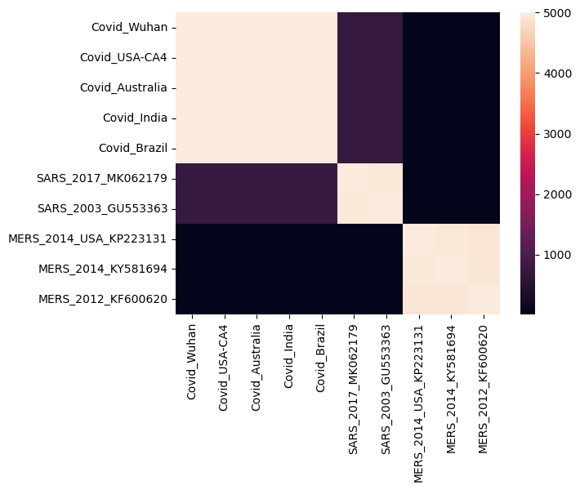

From the heatmap and similarity matrix, we can see the covid strains are really similar to each other. Same goes for SARS strain and MERS strain. We can also deduce that SARS has more similarity to Covid Strains than MERS.

**Performance:**

|  |  |
| --- | --- |
| **Task** | **Time (Seconds)** |
| Generalized suffix tree construction | 713.138 |
| Time to identify fingerprints | 1.4031 |
| Whole Task 1 | 716.12 |
|  |  |

Alignment time for 5000 Characters **(in seconds**):

|  |  |  |  |  |  |  |  |  |  |  |
| --- | --- | --- | --- | --- | --- | --- | --- | --- | --- | --- |
| String | Covid_Wuhan | Covid_USA-CA4 | Covid_Australia | Covid_India | Covid_Brazil | SARS_2017_MK062179 | SARS_2003_GU553363 | MERS_2014_USA_KP223131 | MERS_2014_KY581694 | MERS_2012_KF600620 |
| Covid_Wuhan | - | 300.42 | 59.97 | 303.02 | 270.01 | 269.43 | 264.21 | 262.04 | 288.51 | 249.32 |
| Covid_USA-CA4 |  | - | 249.32 | 80.55 | 274.54 | 315.52 | 306.72 | 344.63 | 304.96 | 282.08 |
| Covid_Australia |  |  | - | 50.00 | 260.10 | 234.13 | 282.91 | 332.98 | 336.46 | 323.45 |
| Covid_India |  |  |  | - | 68.87 | 292.61 | 265.37 | 290.20 | 293.42 | 285.85 |
| Covid_Brazil |  |  |  |  | - | 266.67 | 279.03 | 288.55 | 290.78 | 362.53 |
| SARS_2017_MK062179 |  |  |  |  |  | - | 0.0 | 270.80 | 217.27 | 194.99 |
| SARS_2003_GU553363 |  |  |  |  |  |  | - | 185.74 | 196.06 | 247.39 |
| MERS_2014_USA_KP223131 |  |  |  |  |  |  |  | - | 144.97 | 86.87 |
| MERS_2014_KY581694 |  |  |  |  |  |  |  |  | - | 236.16 |
| MERS_2012_KF600620 |  |  |  |  |  |  |  |  |  | - |